PENETRATION TESTING REPORT
FOOTPRINTING & NETWORK SCANNING PHASES
W2-PM-FINAL | CYBERSECURITY | NETWORKWALKS

Pentester Name : | YOGESH V
Program/Batch | B082-Networkwalks
Date | 19 August 2026
Modules Completed | W2-PM1 (Multiple Kali Tools)  W2-PM2 (GHDB Dorking)  W2-PM3 (Maltego)  W2-PM4 (theHarvester)  W2-PM5 (Zenmap Scanning)
Client/Target | - Networkwalks (with all due permissions)  - My own Local LAN Network
Permission Secured | Yes
Phases Covered | Phase 1: Reconnaissance & Footprinting  Phase 2: Scanning & Network Discovery  Phase 3-5: In Progress

1. Liability Disclaimer
I have performed these activities only on the systems & devices where I had secured written permission or the devices/systems that I own myself. All these materials are for education and research purpose only. Do not use anything from here to break the law. The instructor, the authors and Networkwalks are not responsible for what you do with this knowledge. Every action you take is your own responsibility. Misuse can lead to criminal charges, heavy fines, loss of your job and a permanent record. In most countries unauthorised access is a crime even when nothing is damaged.

2. Introduction
This comprehensive report documents the methodologies, execution, and findings of the footprinting and network scanning phases conducted during Week 2 of the Cybersecurity Internship Program (Batch B082) at Networkwalks. In the lifecycle of any professional penetration test, Phase 1 (Reconnaissance & Footprinting) and Phase 2 (Scanning & Network Discovery) form the critical foundation for all subsequent security assessments. Before attempting to identify or exploit vulnerabilities, an ethical hacker must first quietly gather intelligence to build a complete profile of the target’s digital footprint and map the boundaries of the live network. Together, these phases demonstrate how an attacker moves logically from gathering passive public information to actively mapping live hosts on a target network.

The primary objective of these exercises was to simulate the initial stages of a cyberattack using industry-standard tools and methodologies to understand what sensitive information is publicly exposed. All operations were strictly bounded by the agreed-upon rules of engagement and executed within authorized environments, including the networkwalks.com domain for external reconnaissance and a locally owned network for internal scanning.

To achieve a comprehensive assessment, the testing was divided into five distinct modules, each focusing on a different vector of intelligence gathering:

- Active and Passive Footprinting (W2-PM1): This module focused on extracting foundational domain data. Using a suite of Kali Linux commandline utilities, the target domain (networkwalks.com) was interrogated to reveal domain registration details, web server technologies, HTTP headers, Web Application Firewall (WAF) configurations, and DNS infrastructure records.

- Google Hacking Database Reconnaissance (W2-PM2): This phase demonstrated the power of advanced search engine operators (dorks). By utilizing GHDB queries, the assessment highlighted how misconfigured servers inadvertently leak highly sensitive information—such as administrative camera portals and open file directories—directly to public search engines.

- Entity Mapping and Link Analysis (W2-PM3): Moving beyond raw data, this module utilized Maltego to graphically map the target's infrastructure. This exercise translated raw WHOIS and DNS data into visual relationship graphs, allowing for the rapid identification of administrative contact points and organizational structures.

- Open-Source Intelligence Aggregation (W2-PM4): Utilizing theHarvester, this phase focused on passive metadata collection against a large-scale scope (microsoft.com). The goal was to scrape search engines and public databases to enumerate hidden subdomains, employee email addresses, and potential phishing targets without directly interacting with the target's servers.

- Network Discovery Scanning (W2-PM5): Shifting from external footprinting to internal reconnaissance, this final module utilized Zenmap (the graphical interface for Nmap) to conduct ICMP ping sweeps across a local 10.0.0.0/24 subnet. This step successfully identified live hosts, extracted hardware MAC addresses, and generated a structural topology map of the network.

All external footprinting commands were executed within a Kali Linux environment, while internal network scanning was conducted from a Windows host. The following sections of this report will detail the specific tools utilized, the step-by-step activities performed, the evidence collected, and a comprehensive risk analysis of the findings from an attacker's perspective.

3. Tools Used
The table below lists each tool used in this report and its purpose.

Tool  Kali Linux  WHOIS  WhatWeb  nslookup  curl -I  wafw00f  dnsrecon  GHDB /  Google  Maltego  theHarvester  Zenmap | Purpose  Operating system used for reconnaissance activities.  Find domain registration details (owner, dates, name servers).  Fingerprint web technologies (server, CMS, plugins, IP).  Resolve the domain name to its IP address using DNS.  Read the HTTP response headers of the website.  Detect whether a Web Application Firewall protects the site.  Enumerate all DNS records (NS, MX, SPF, TXT, SRV).  Leverage advanced search operators (dorks) to find exposed files and devices.  Graph-based open-source intelligence and forensics application.  OSINT tool to gather emails, subdomains, hosts, and employee names.  Scan the local subnet to find live hosts, IPs and MAC addresses.

4. Activities Performed

4.1 Footprinting & Reconnaissance (Kali Tools)

I performed reconnaissance against the networkwalks.com domain using six Kali Linux tools.

- WHOIS: Obtained publicly available domain registration information, confirming GoDaddy as the registrar.

- WhatWeb / Nslookup / Curl / Wafw00f: Fingerprinted the web stack, identifying WordPress 7.0.4, WP Download Manager 3.3.58, and an Apache server hosted at IP 192.232.216.135. The site is successfully protected by a ModSecurity (SpiderLabs) Web Application Firewall.

- DNSRecon: Enumerated the domain's DNS records, locating MX records (mail.networkwalks.com) and cPanel auto-discover SRV records.

4.2 GHDB Based Footprinting Attacks

I utilized Google Hacking Database (GHDB) dorks to uncover exposed network devices and open directory listings indexed by search engines :

Task 1: Exposed Security Cameras
(Target IP addresses have been sanitized for reporting purposes).
No. | Link | Relevant Dork | Username /Password  (if any)
1 | http://109.233.191.130:8080/ | intitle:"webcamXP 5" inurl:admin.html | ---
2 | https://www.lmc.edu/webcam.htm | intitle:"Webcam" inurl:WebCam.htm | ---
3 | http://www.insecam.org/en/bytype/webcamxp/ | intitle:"webcamXP" inurl:8080 | ---
4 | http://109.233.191.130:8080/multi.html | intitle:"webcamXP" inurl:8080 | ---
5 | http://72.199.200.5:8080/?src=1&mode=0 | intitle:"webcamXP" inurl:8080 | ---
6 | http://myfishcam.homedns.org:444/ | intitle:"webcamxp" "Flash JPEG Stream" | ---
7 | http://125.236.232.93:9007/cgi-bin/guestimage.html | "Camera Live Image" inurl:"guestimage.html" | ---
8 | http://75.149.26.30:1024/ | intitle:"webcamXP 5" inurl:8080 'Live' | ---
9 | https://www.earthcam.com/usa/northcarolina/newbern/?cam=newbern_nc | inurl:"live/cam.html" | ---
10 | https://www.cameraftp.com/cameraftp/publish/camera.aspx/parentID75626514/shareID12935277/modelive/nameupperdeck/camTypeCamera | inurl:"view.shtml" "camera" | ---

Task 2: Downloadable Maths Ebooks

No. | Link | Relevant Dork | Username /Password  (if any)
1 | https://www.skylineuniversity.ac.ae/pdf/math/ | intitle:index.of "parent directory" mathematics pdf | ---
2 | http://erewhon.superkuh.com/library/Math/ | intitle:index.of "parent directory" mathematics pdf | ---
3 | https://sajaipuriacollege.ac.in/pdf/pdf/MATHEMATICS/ | intitle:index.of "parent directory" mathematics pdf | ---
4 | https://www.jsoftware.com/books/pdf/ | intitle:index.of "parent directory" mathematics pdf | ---
5 | https://math.dartmouth.edu/~carlp/PDF/ | intitle:index.of "parent directory" mathematics pdf | ---
6 | https://www.netlib.org/math/docpdf/ | intitle:index.of "parent directory" mathematics pdf | ---
7 | http://inis.jinr.ru/sl/vol2/Mathematics/Math.Encyclopedia/Pdf/ | intitle:index.of "parent directory" mathematics pdf | ---
8 | https://education.giakonda.org.uk/Maths/ | intitle:index.of "parent directory" mathematics pdf | ---
9 | https://maths.nuigalway.ie/~rquinlan/linearalgebra/ | intitle:index.of "parent directory" mathematics pdf | ---
10 | https://ochicken.net/library/Mathematics/ | intitle:index.of "parent directory" mathematics pdf | ---

4.3 Entity Mapping (Maltego)
Using Maltego, I executed an infrastructure mapping workflow against a target domain (maltego.com). Utilizing the To Email address [From whois info] transform, I successfully enumerated a linked contact point (abuse@godaddy.com), demonstrating how passive WHOIS data can be visually graphed to identify administrative targets.

4.4 OSINT Aggregation (theHarvester)
I utilized theHarvester to perform passive reconnaissance against microsoft.com.

- Running a query limited to 1000 results via the baidu data source, I successfully extracted one corporate email address (vivanoreply@microsoft.com) and four subdomains (including hxd.research.microsoft.com and watson.microsoft.com).

- A subsequent broad search using the all data source highlighted the necessity of configuring API keys, as sources like BeVigil, Shodan, and GitHub Code returned missing key errors.

4.5 Network Scanning with Zenmap
I used Zenmap to perform network discovery on a local 10.0.0.0/24 subnet. Using a standard Ping Scan (nmap -sn 10.0.0.0/24), I successfully identified three active hosts on the network: 10.0.0.5 . I subsequently mapped these nodes using Zenmap's Topology generator.

5. Risk Analysis / Impact (● Critical ● Medium ● Low)
Based on the information collected, I identified the following potential risks.
No. | Risk / Finding | Evidence | Potential Impact | Risk Level
1 | Web  technology information  exposed | WhatWeb identified  WordPress 7.0.4 and WP  Download Manager  3.3.58 | Attackers may use exposed technology/version information to identify software requiring further security review | ● Medium
2 | WAF  technology  identifiable | Wafw00f identified  ModSecurity  (SpiderLabs) | Reveals information about the web application’s  security architecture | ● Low
3 | DNS  infrastructure information  exposed | DNSRecon identified MX, TXT, and cPanel SRV  records | DNS information can help build a broader infrastructure profile | ● Medium
4 | Sensitive  Directories &  Devices  Indexed | GHDB queries uncovered open internal webcams and file directories | Unauthenticated access to hardware and internal files by malicious actors. | ● Critical
5 | Employee  Emails &  Subdomains  Leaked | theHarvester exposed vivanoreply@microsoft.com and internal hosts | Can be leveraged for targeted phishing campaigns or uncovering undocumented attack surfaces. | ● Medium
6 | Multiple live hosts visible on  local network | Zenmap identified 3 live hosts (VirtualBox/QEMU nodes) | Unknown or unauthorized devices may potentially be  present on a network | ● Medium

6. Recommendations

- Review publicly exposed technology information: Organizations should regularly review what information about their web technologies, CMS and plugins is publicly visible.

- Properly configure and monitor the WAF: Keep the WAF (ModSecurity) enabled and tuned, since it already blocks naive attacks.

- Implement Search Engine Controls: Ensure robots.txt files and noindex meta tags are properly configured to prevent sensitive directories (like internal PDFs or hardware portals) from being cached by Google.

- Manage Digital Footprint: Routinely run OSINT tools like theHarvester to ensure sensitive corporate emails and internal development subdomains are not inadvertently indexed by public search engines.

7. Conclusion
During Week 2 of my Cybersecurity & Ethical Hacking internship, I successfully executed practical activities spanning multiple OSINT, footprinting, and scanning vectors. I demonstrated the ability to extract technical telemetry from web applications using CLI tools, leverage GHDB for passive device discovery, mapped infrastructure visually with Maltego, scraped open-source intel with theHarvester, and conducted internal subnet mapping with Zenmap. These exercises reinforced that a security professional can learn a significant amount about an environment by carefully analyzing publicly available information and network responses prior to any direct exploitation.

8. Evidences Collected

Evidence 1: Domain WHOIS Information

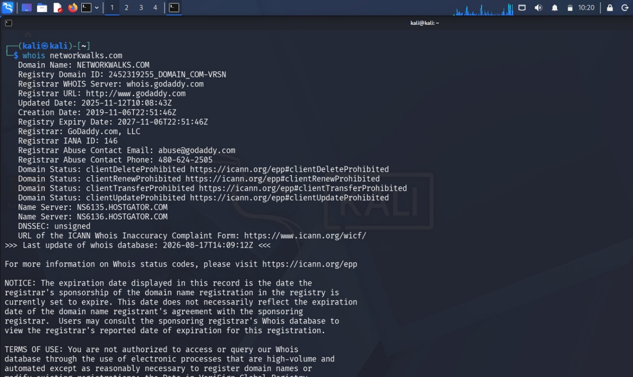

Evidence 2: WhatWeb, Nslookup, Curl, and Wafw00f Output

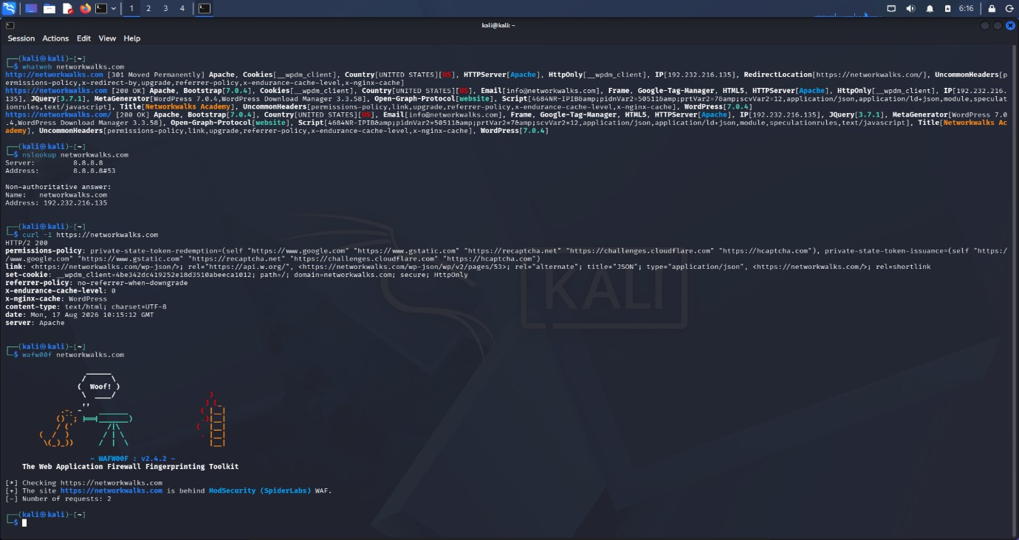
Evidence 3: DNSRecon Records Enumeration

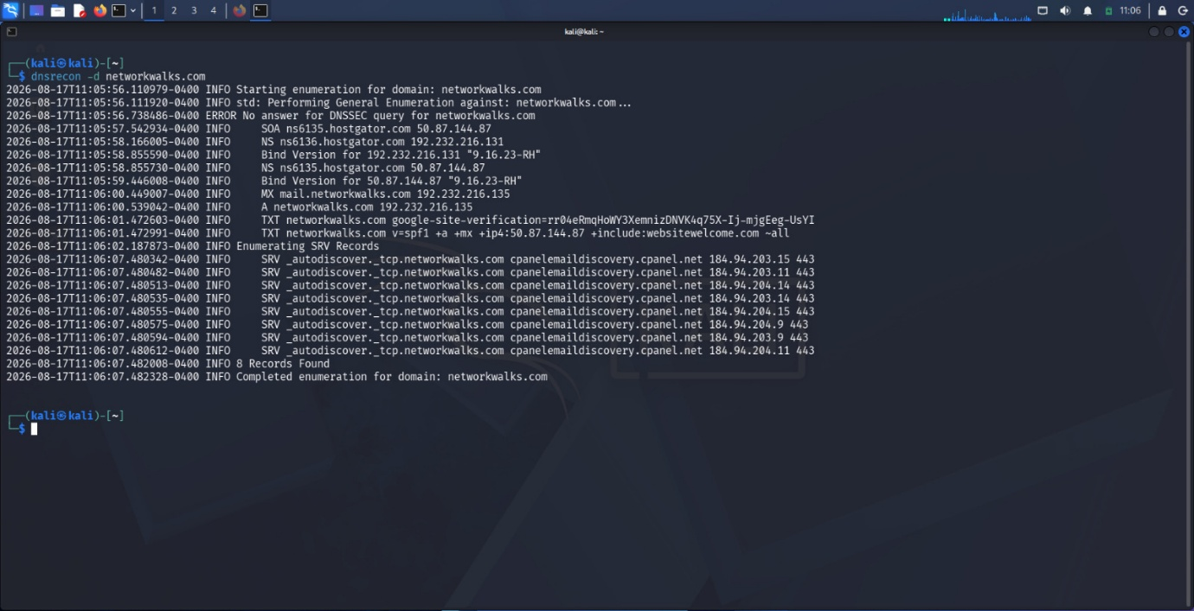

Evidence 4: Maltego Hub & Tool Initialization

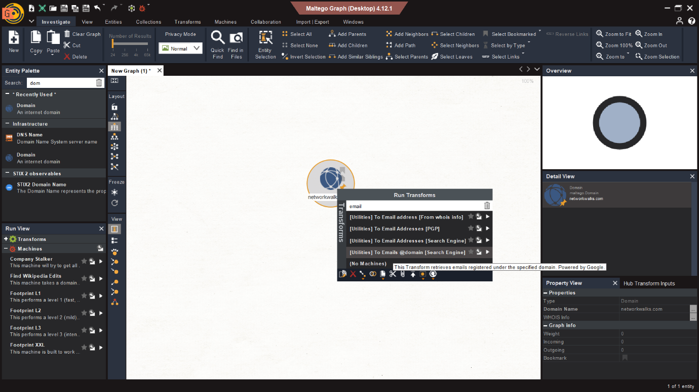

Evidence 5: Maltego Visual Graph & Email Extraction

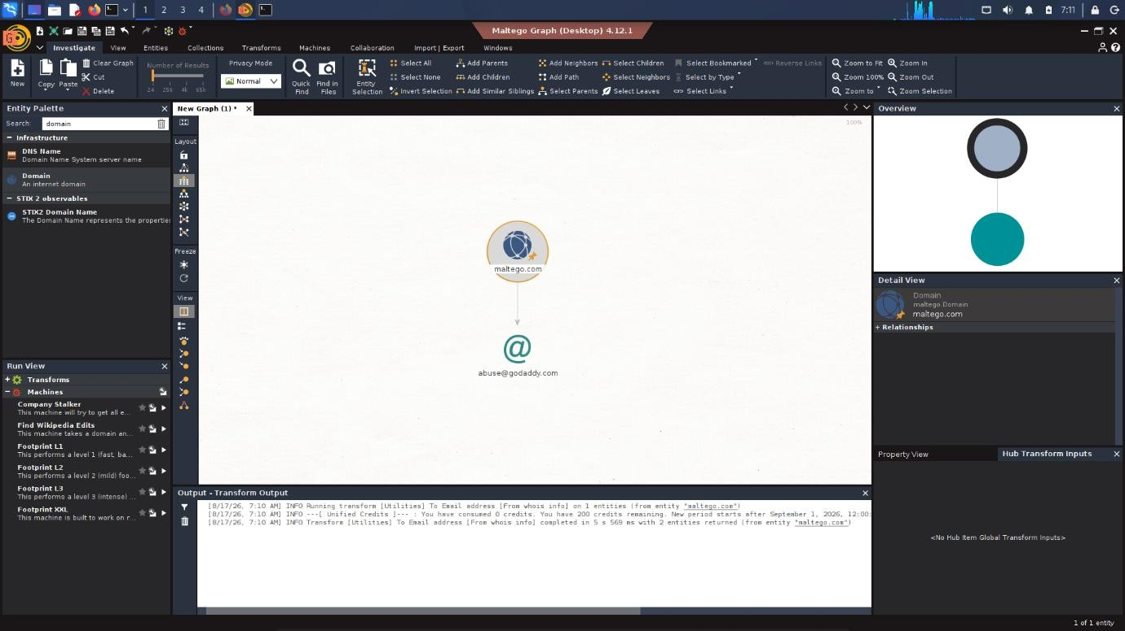

Evidence 6: theHarvester Help Menu & Syntax

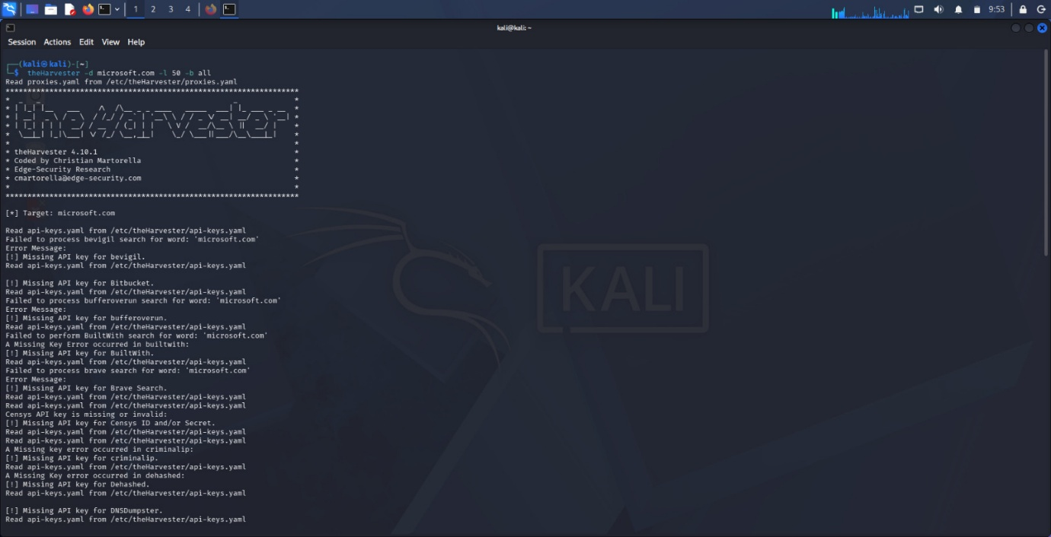
Evidence 7: theHarvester Data Extraction (Baidu Source)

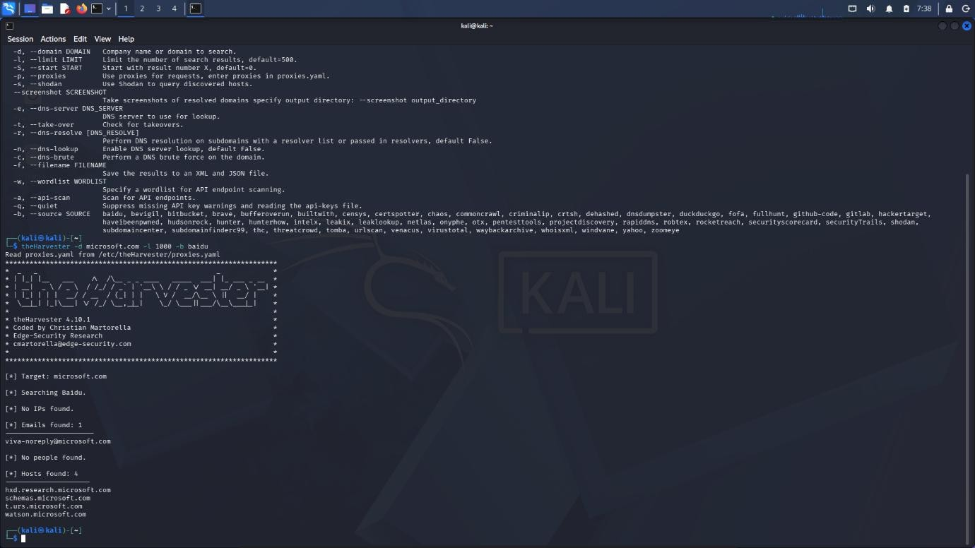

Evidence 8: theHarvester Missing API Keys Demonstration

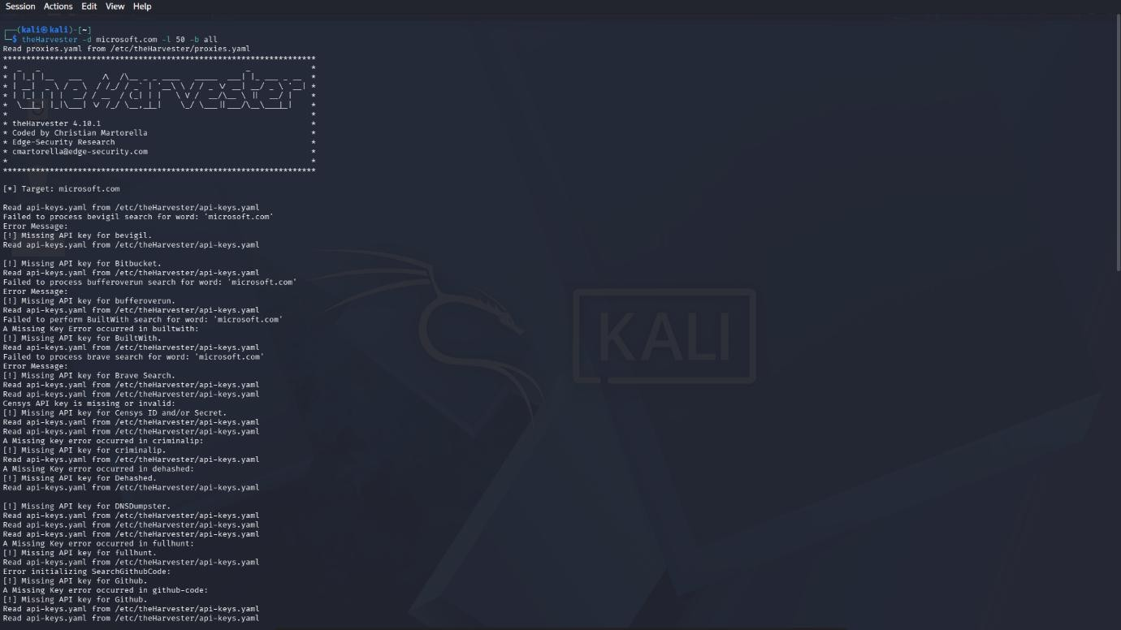
Evidence 9: Zenmap Local Ping Scan Execution

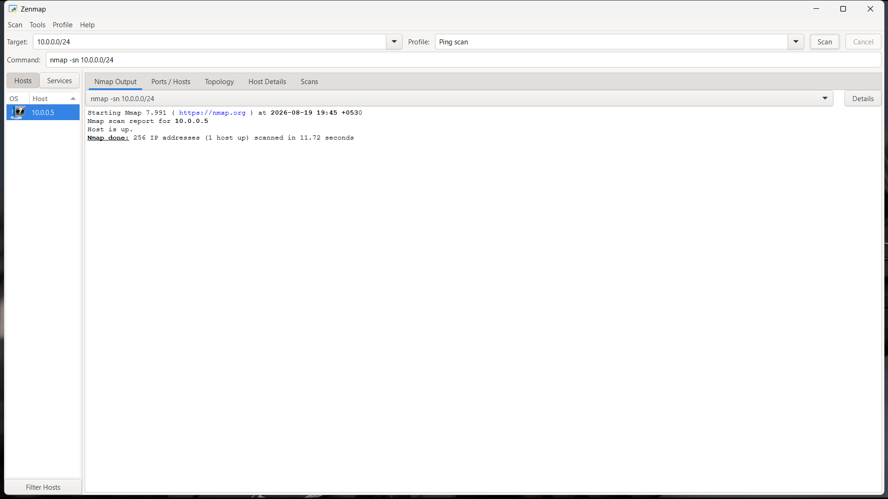

Evidence 10: Zenmap Local Network Topology Graph

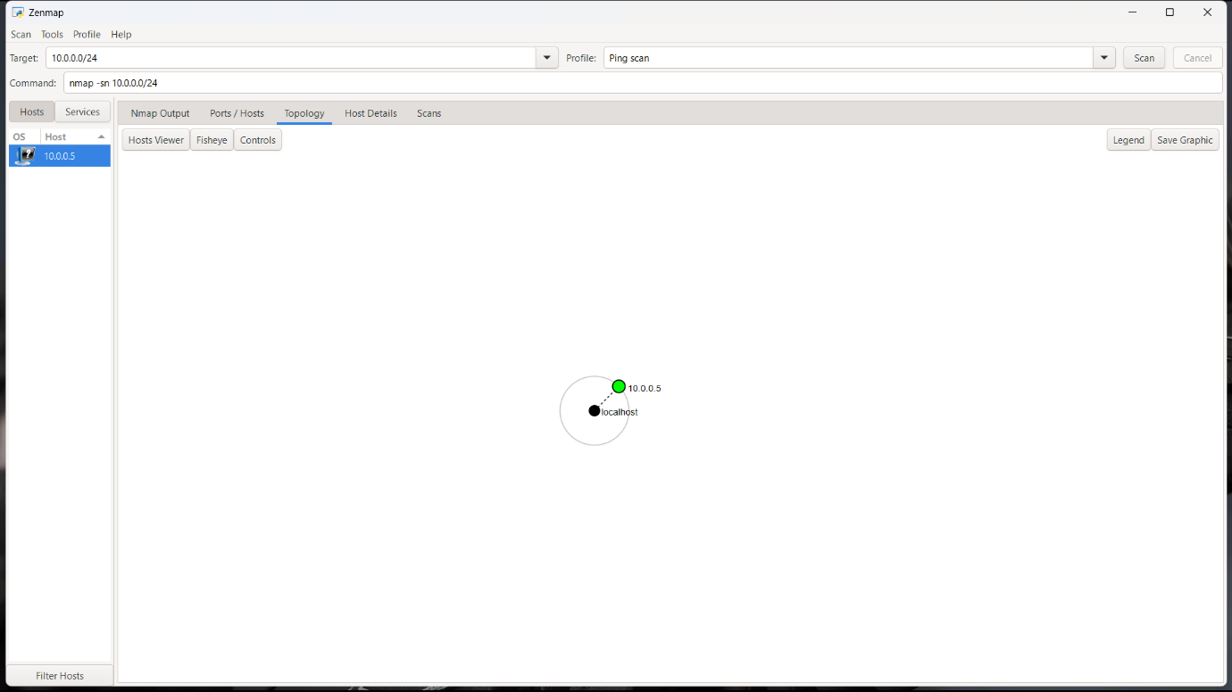

-END-

👤 Author
WaqasKarimCCIE
Cybersecurity Professional B082
LinkedIn: https://www.linkedin.com/in/waqaskarim/

📌 Project Information
Program Name: Cybersecurity program at Networkwalks
| Week: 02 | Repository: GitHub

